Database Management System

# What is a Database Management System (DBMS)?

A **database management system** is a software for creating and managing databases. The DBMS provides users and programmers with a systematic way to create, retrieve, update and manage data.

# What does the project show?

In this project we have implemented a simulation of a DBMS in C++ by defining our own commands with a command-line type interface.

We have defined the following commands:

* help
  + Gives details on the other commands
* create
  + Used to create databases/tables
* insert
  + Used to add columns to the table
* delete
  + Used to delete tables, records and columns
* show
  + Used to show details of databases, tables
* use
  + Used to switch to a different database

# Class Diagram

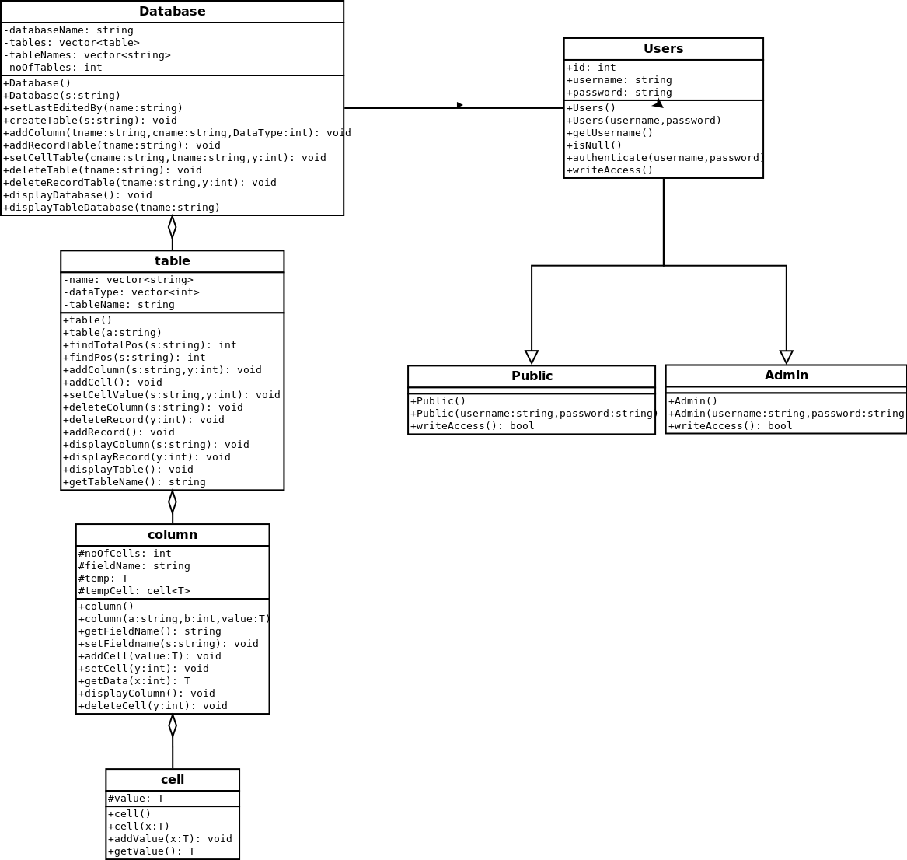

# List of OOP Concepts Used:

* **Encapsulation**
  + All data pertaining to a certain database or table has to be stored in that database or table and must be accessible only by the functions from that database
* **Abstraction**
  + Our program ensures that all data is hidden and is retrieved only through the right methods
* **Polymorphism**
  + To handle different types of data (Integer, Floating-Point and String) but at the same time maintain a Standard Template for the data, certain polymorphism techniques have been used.
* **Inheritance**
  + To have two types of users in our DBMS, Admin and Public, we had to implement inheritance techniques as well use virtual functions to resolve to the right method.
  + Admin rights
    - Modify the structure of the database
    - Modify the data in the database
  + Public rights
    - Modify the data in the database

# List of OOPs elements used:

* Templates
  + Used to input different datatypes using same function
* Virtual Functions
  + Used to overwrite the functions in Admin and Public inherited from User
* Function Overloading
* Inheritance (Base and Derived Classes)
  + Used to give a basic structure to Admin and Public
* Exception Handling
  + Used to catch various possible predefined errors
* Base to Derived Class Pointer
  + Used to create
* Encapsulation
* Polymorphism